In Memory of

Walter "Bud" Conrad Swanson
April 9, 1920 - April 6, 2015
Obituary

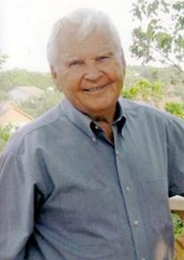
Walter Conrad (Bud) Swanson died peacefully at home the afternoon of April 6, 2015. He was the youngest child of Charles Conrad and Amanda Ekberg Swanson, born on April 9, 1920 in Austin, Texas. He is survived by his wife, Helen Robisher Swanson, whom he married on May 24th, 1942, and his children, Richard Swanson, Susan Hutchison, and Bob Swanson. Bud is also survived by 5 grandchildren and seven great grandchildren.
Bud was very active and a sports enthusiast all of his life. He was an All-state guard for Austin High School from which he graduated in 1938. He met Helen in high school and their love lasted for over 77 years. He was an Eagle Scout and served in World War II as a bomber pilot in the European Theater and later as an instructor pilot. After the war he joined the Texas Employment Commission where he served in various capacities until his retirement in 1980. He served as a reserve officer in the United States Air Force and retired with the rank of Lt. Colonel. Bud was a member of Covenant Presbyterian Church and through the years he served as an Elder and Deacon in the Presbyterian Church. He was proud of the fact that he was retired longer than he had worked, since his retirement was so active and productive. Bud and Helen traveled to Canada, twice to Sweden and many places in the United States often participating in the reunions of the 303rd Bomb Group. Several times one or more of their children were privileged to accompany them. Bud also was an artisan making many fine pieces of stained glass, wood, and refinishing "treasures" he found in various places. He happily shared many of these with friends and family members. He and Helen loved the time they spent together at their house in the country and shopping for art and antiques with friends when they could. Bud played tennis until, at 92, an elbow condition required that he discontinue playing.
Bud will be remembered as a loving and caring son, brother, husband, dad, grandpa, uncle, brother-in-law and friend. He will be sorely missed but his influence on the lives of his family and friends will continue for many years to come.

