TALES OF A HELL’S ANGEL

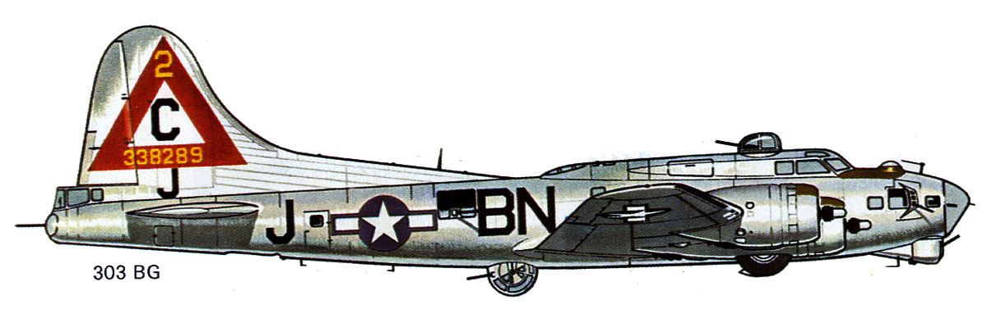

THE TRUE STORIES OF STAFF SERGEANT ELYWN JONES DARDEN’S SERVICE IN THE 303RD BOMB GROUP DURING
WORLD WAR II
BY BOB DARDEN

Backgrounder
My Dad, Elwyn Jones Darden, was a radio operator on a B-17 bomber in the U.S. Army Eighth Air Force in England during World War II.
This is an attempt to catalogue some of the stories that he told us when we were kids.
Dad was a member of the 303rd Bomb Group (Hell’s Angels) based in Molesworth, England. His crew was assigned to the 359th Bomb Squadron. His serial number was 34621609.
His crew included Jack Bailey, pilot; Guy Hall, co-pilot; David “Moose” Johnson, bombardier; Glen “Swede” Swenson, navigator; Carl Muller, top turret/engineer; Billy McGuire, waist gunner; Donald Geng, ball turret gunner; and Merle Eckert, tail gunner. In this photo, Dad is first from the left on the front row, followed by Muller, McGuire, Eckert and Geng. In the second row from the left are Bailey, Hall, Swenson and Johnson.
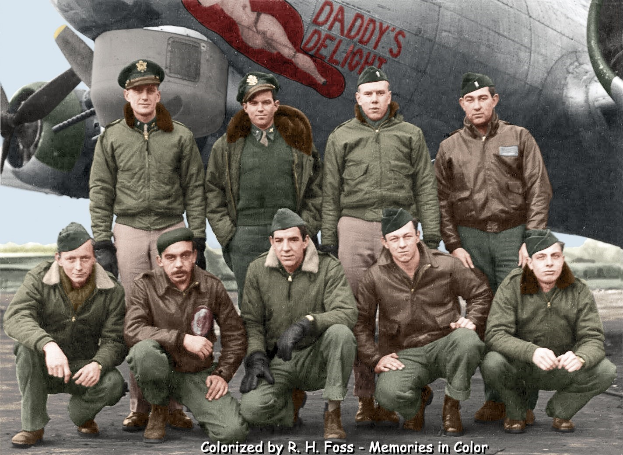
Bailey, Hall, Johnson and Swenson were 2nd Lieutenants, while the others were “flying” sergeants. Because of a “no-fraternizing” policy, officers weren’t allowed to be close-knit buddies with their crews.
I came to learn from Merle Eckert that Bailey was able to interview and personally hand-select his crew. That might explain why Swenson and Geng came from Minnesota and Hall and my dad were from Mississippi. Hall was from Greenwood, and Dad was from Hernando.
Training
My Dad didn’t take too kindly to basic boot camp.
He recalled that the sergeant had given the cadets explicit instructions on how to clean the barracks and make quarters bounce off a perfectly made cot.
One day, during a general inspection, the sergeant donned a white glove and went straight to the rim of the toilet bowl. When the glove came up dirty, the whole cleaning process had to begin again.
When it came time to shoot at clay pigeons, my Dad was prepared from his boyhood. He had been shooting birds with a .22 rifle since he was 10.
After a day of busting clays, the shoulders of some of the guys—the “Yankees,” who were not experienced enough to hold the gun’s buttstock tightly against their shoulders—looked like ground hamburger meat, he said.
I read elsewhere that this aerial training also involved shooting shotguns from flexible mounts in jeeps. As the jeep moved along the target course, clay pigeons came out from concealed positions. The trainees were expected to successfully spot, lead and shoot the pigeons along the course.
As the training advanced, the trainees shot at targets towed by planes using .50 caliber Browning machine guns.
My Dad was proud to say he could field strip a .50 caliber machine gun blindfolded and put it back together again in, I think, under a minute.
During this time, my dad was introduced to several different U.S. bombers.
He liked the Douglas A-20 Havoc, a small, nimble three-man plane with two engines. He also liked the twin-engine Martin B-26 Marauder medium bomber.
He was not impressed with the North American B-25 Mitchell medium bomber because it had an enclosed bomb bay that one had to crawl over in order to reach the pilot and co-pilot. Nor did he like the Consolidated B-24 Liberator heavy bomber with its Davis Wing.
The Davis Wing was vulnerable to enemy anti-aircraft fire, he said.
Of all the bombers, the B-17 Flying Fortress, a heavy bomber, was the one dad liked best. It had the reputation of being a tough, dependable bird.
A nice feature was the B-17’s separate radio compartment (with skylight).
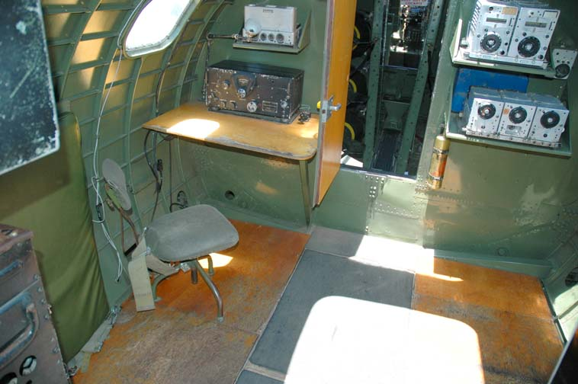
Dad’s “office,” the B-17’s radio compartment. Directly ahead is the catwalk over the bomb bay (bombs—green with yellow stripes—are visible).
My Dad also served as a waist gunner, with a single .50 caliber machine gun.
One day, during a training flight over the Gulf of Mexico, Dad’s .50 caliber was the only one working on the plane.
As each man fired the air-cooled gun round-after-round, the barrel began to turn cherry red. Pouring water on the barrel would only crack it, he said.
Dad said if the crewmember cracked the barrel, he would be docked for it.
Still, the crew had boxes and boxes of ammo left to shoot.
Since they weren’t being observed by their instructors, the crew simply opened the bomb bay doors and chucked the unfired ammo out into the Gulf of Mexico.
The training involved being at several air bases in the states, including one at Roswell, New Mexico. One day, the temperature at a base (I believe it was in Alexandria, Louisiana) was so hot that the asphalt runway melted under their feet, Dad said.
At another air base, my dad once spotted off in the distance a big bomber. It must have been the brand-new B-29 Superfortress, which saw action exclusively in the Pacific.
A Little Too Close for Comfort
On one training flight over Mississippi on Friday, October 13, 1944, my Dad got up into the nose of a B-17 to look down on his hometown of Hernando.
The training involved P-63 Kingcobra fighters, piloted by veteran fighter pilots, who wove in and around the bombers, simulating attacking German fighters.

One of the P-63s made a pass, miscalculated and collided with the nose of the aircraft next to Dad’s—shearing off the nose and killing the navigator and bombardier, who were in the plane’s nose. The two planes crashed, and another B-17 was damaged, according to official records.
Co-pilot Guy Hall wrote about this incident in his autobiography, From Here to There (and Along the Way).
Hall described the crash as happening near Greenwood, but Hernando and Greenwood are more than 100 miles apart. It might have been a type of training technique involving the fighters taking “gun camera” footage of the bombers. Hall said the fighters, again piloted by veterans, were from the Greenwood Army Air Field.
Dad, however, specifically mentioned the P-63s in his story.
An interesting side note on the Greenwood Army Air Field is that one of the training instructors at Greenwood was future crime novelist Mickey Spillane.
Doda and the Crew’s Departure for England
Donald Geng told a funny story about my grandmother, Josie “Doda” Darden.
When the crew was about to depart from New York City on the Queen Mary, Doda boarded a train and made the more than 1,000-mile journey from Hernando to New York City accompanied by her black maid.
The black Pullman porters along the route made sure the women never got on the wrong train for the duration of the trip, despite the numerous transfers that were required.
Merle Eckert said he remembered joking with Doda. According to him, these were sophisticated, mature jokes. He said she seemed to enjoy the exchange.
Crew Bonding
During the training, my Dad said he became good friends with Billy McGuire, the plane’s full-time waist-gunner.
They shared the same “office” on the plane when the plane was under attack by fighters—the waist gun positions.
When my Dad bailed out over Nazi Germany, he was seriously wounded. When he came to, Billy was carrying him in a German Kubelwagen.
McGuire was from Massachusetts. After the war, he received a diploma in psychology. I learned that from his family sometime in the early 2000s.
My Dad never described himself as being really close to any other member of the crew.
He did say he and Merle Eckert once went to London on R&R and hung out with some British girls.
Top turret gunner Carl Muller was a veteran of the Pacific Theater, and he replaced the original top turret gunner, who I believe was a man named Thuss.
As I said earlier, officers were discouraged from forming bonds with enlisted men and sergeants.
Donald Geng was slightly younger than the others in the back of the plane. Eckert said he considered Geng just a bit too “green” to associate with.
Facing Facts
Eckert gave a dramatic glimpse into the nature of combat missions in late 1944.
He said there was another young crew—they might have even trained together—that was lost on its very first mission over Germany.
To keep the other crews from dwelling on these losses, it was Air Force policy that the personal effects of the downed crews were removed quickly from the barracks. Some of the items were sent to the families of downed crewmembers, while other items stayed behind—like the .45 caliber 1911 Colt automatic pistol issued to each airman.
Dad said the aircrews were not issued ammo for the pistols, nor holsters. They also were warned that if they were shot down and caught carrying a weapon, they would be considered spies and shot.
Once my Dad’s crew put all their pistols into a footlocker and told a neighboring crew in the barracks that if they were shot down, to take the guns home as souvenirs. One guy from the other crew spoke up. “That’s OK, you all just come back,” my Dad recalled the man saying.
Dad described the .45s as cheap, since they “rattled” when shaken. He apparently did not know that all .45s rattle because of recoil springs, a swinging link barrel and looser slide tolerances.
Sometimes my Dad said he performed guard duty at the base, with an unloaded M-1 carbine.
In the Mess Hall, my Dad said, what he missed most of all was fresh milk.

Combat Missions
After the morning’s briefing, all non-com members of the crew were expected to manually turn the plane’s propellers prior to start-up—the pre-warm-up-warm-up, if you will.
My Dad said his job on the plane was to maintain radio silence on the first leg of the mission and render plane position reports every 30 minutes.
He also dispensed chaff—shredded aluminum foil—intended to hamper German radar from locating the bomber formation. I’m not sure, but I believe all the planes dispensed the chaff at the same time. Dad dropped the chaff out of the plane’s bomb bay.
Once the mission was completed, he signaled in code that his plane had dropped its bombs.
He also dispensed sandwiches and coffee to the crew. The radioman was also in charge of the plane’s first-aid satchel.
On one mission, Dad’s plane experienced a blown tire during take-off.
The tower told Bailey to taxi to the end of the runway while the remaining planes in the formation took off one after another. Dad said he could look up through the skylight in the radio compartment and see the blue super-chargers of the other planes as they whizzed pass, seemingly just a few feet overhead.
After the squadron took off, Dad’s crew was given a replacement plane and was expected to continue with the mission.
Eckert said my Dad described some missions as “white-knuckle missions,” where the target was heavily-defended by both fighters and flak guns on the ground.
Unlike movies, such as 12 O’Clock High and The War Lover, the crews, by this time in the air war, wore helmets, goggles and flak jackets similar to those worn by the B-24 pilot in the photo below.
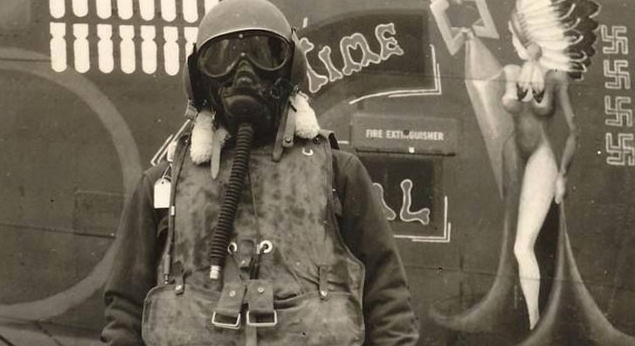
The helmet contained the intercom’s headphones, and in addition, each crew member had a “throat mic” to communicate with other members of the crew. The crew also wore parachutes. The chute is shown on the front of the pilot in the photo. The days of the “50 Mission Crush Caps” and leather bomber jackets were over.
The crew members used portable oxygen bottles to move about the ship, and when they reached their stations, they could connect to the plane’s main oxygen system. Again, in this photo, you can see the oxygen hose. Switching to oxygen happened around the height of 10,000 feet.
All crew members had to check on each other from time to time to prevent an improper oxygen mix or icing within the mask.
Some missions involved bombing “marshalling yards,” which is just a fancy name for railroad yards.
Dad remembered one mission to Berlin involved a “peace monument” that was used as the reference point to begin the bomb run.
The group’s lead bombardier selected the point for bombs away, and a flare was fired. As each plane came abreast of the flare’s location, they simply “toggled” their bombs.
Bombardiers weren’t essential for individual planes. This meant that any crewmember could release bombs when assigned as the “togglier.”
My Dad said he had been the togglier on several missions.
(For a complete listing of the Bailey crew’s missions, see Appendix A.)
After a mission was completed, each of the crews was debriefed by ground officers. They might discuss topics such as concentrations of flak and enemy fighters, the escort fighters or even the purpose of the mission itself.
Something that was unusual in the Army Air Force was that all crew members—regardless of rank—could freely express their views on what went wrong with a mission within the confines of the debriefing session. In other words, a staff sergeant could question the wisdom of the bomb group’s highest-ranking officers.
Once, Bailey’s plane was forced to land at a British aerodrome. The Royal Air Force (RAF) flew at night and was just getting ready for supper, so the crews had a chance to interact. The British air crews referred to the Americans as “Yanks,” in a good-natured ribbing way. Dad told them he was a “Rebel,” not a “Yank.”
Eckert said he was allowed to look over a tail gunner position on a Lancaster heavy bomber. The puny .303 caliber Vickers quad machine guns had neither the range nor the lethality of the American twin .50 caliber Brownings.
The Fatal Mission: Number 313
According to 303rd Bomb Group’s website, Mission No. 313 was the crew’s final mission. They completed 17 missions in all.
On that fateful mission on Feb. 9, 1945, Billy McGuire served as the togglier.
Glen Swenson was the lead navigator on that day. He was in the bomb group’s lead aircraft. Also, David “Moose” Johnson was a group bombardier by that point.
The target on Mission No. 313 was a synthetic oil plant in Lutzkendorf that was heavily defended. As the lead group on the bombing run, the 359th bore the brunt of flak as it approached the target.
The official report, which is on the www.303rdbg.com/ website, described what happened to Dad’s plane:
B-17G #43-38764 (No Name), 359BS, piloted by 2Lt. Jack W. Bailey, was hit by gunfire on the Nos. 2 and 3 engines at “bombs away.” The No. 2 engine was feathered immediately, but it took some time before the pilot could feather No. 3. The aircraft, unable to maintain formation, lost altitude and began to straggle. In the vicinity of Mulhausen, Germany, it encountered about 14 enemy aircraft. Believing the aircraft to be defenseless, the pilot ordered his crew to bail out. Seven crewmen obeyed his order, assuming that they were near Kassel, Germany (P-51 pilots from the 20th Fighter Squadron reported the bail-out to be Mulhausen, Germany). While co-pilot 2Lt. Merwin G. Hall inspected the Fortress to ascertain that all crewmen bailed out, four P-51s appeared and drove off the enemy aircraft. Lt. Bailey's original Navigator, 2Lt. Glen R. “Swede” Swenson, was flying as the lead GH-Navigator with Capt. William E. Eisenhart’s lead crew. A crewman remarked “there go your buddies, Swede.” Lts. Bailey and Hall decided to attempt to bring their damaged B-17 back to friendly territory. They succeeded, bailing out near St. Trond, Belgium, and returned to Molesworth. The pilotless Fortress made a wheels-up belly landing near the hamlet Boekholt of the city of Straelen in Germany, just a few miles from the Dutch border. It was reported as 90% damaged.
As soon as the 14 Me-109s were spotted, Dad said, Bailey ordered the crew to bail out.
The German planes, Dad said, had begun to line up one after another in an effort to perform a “pursuit curve” against the crippled ship. Once the fighters began to attack, each one would make a pass and raked the ship with cannon and machine gun fire.
As the planes approached, top turret gunner Carl Muller shouted over the plane’s intercom, “That’s no way to get the Silver Star,” and began firing at the approaching enemy planes.
Eckert said Muller was simply doing “ranging shots” to determine how far off the 109s actually were. Anyway, the effort was short-lived.
Eckert made sure the crew in the back of the plane got the abandon-ship order from Bailey.
Because the plane was defenseless and in what was referred to as a “tail-end Charlie” (straggling) position, Bailey lowered the plane’s landing gear.
This signaled to the approaching German fighters that the crew intended to bail out. As a courtesy, the fighters refrained from shooting the plane down until after the crew had bailed out.
In some instances, the planes had to land because crewmen were too seriously wounded to parachute.
The Germans often used these captured American bombers as a way to learn the plane’s defensive weaknesses. They also used them to track American bomber formations on their way to and from targets. It was a standing order for American fighters to destroy any captured planes, whether in the air or on the ground.
One such Nazi-captured B-17 was Wolfe Hound, a B-17F, which came from the 303^{rd’s} own 360th Bomb Squadron.
.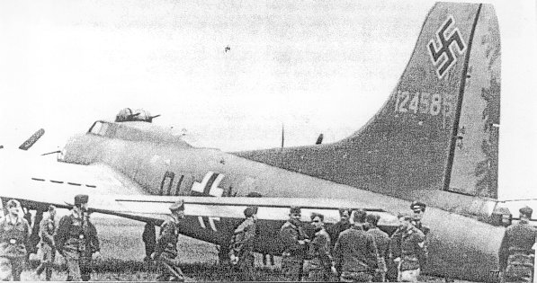
The captured Wolfe Hound displaying its Nazi markings

The “Bloody Hundredth”
One of the stories Dad told us was about the 100th Bomb Group.
A rumor held that once upon a time a bomber from the 100th Bomb Group was beset by fighters. The bomber lowered its landing gear as a sign of surrender. As the German planes pulled alongside the bomber to escort it to an aerodrome, the bomber crew opened up. Several of the approaching planes were shot down. The fighters quickly retreated and then came in for a full-on attack.
In Decision Over Schweinfurt: The U.S. 8th Air Force Battle for Daylight Bombing, author Thomas M. Coffey tracked down a member of the 100th Bomb Group, Lt. Ernest Warsaw, a navigator on a crippled Fortress, who provided information on possibly how the “Bloody Hundredth” rumor got started. Warsaw’s own ship might have been involved.
Warsaw said, as he was calculating the crippled plane’s returning flight path, he heard a gunner say over the intercom:

“A whole squadron coming up at six o’clock!”, Coffey reported.
When Warsaw looked out of the side windows, both left and right, he saw a strange mixture of German planes, twelve or thirteen of them, M-109s, ME-110s, FW-190s, Junkers 88s, and other types. All were sliding in close, throttles back, as if they intended to fly formation with the B-17. . . Everyone who could get to a gun, including Warsaw, opened fire. Warsaw said her personally shot down three of the planes.
The German planes quickly pulled back. When they returned, they riddled the Warsaw’s plane with cannon and machine gun fire.
Warsaw said, as he was preparing to jump, he noticed the plane’s wheels were down for some unknown reason.
Coffey continued:
After his capture, Warsaw, who spoke fluent German, was paid a visit by a drunk German Luftwaffe captain.
Though apparently friendly with Warsaw, he was angry at “some son of a bitch” who had “shot me down after his plane surrendered.”
As the captain loudly described the B-17 that had put its wheels down and then opened-fire with all its guns. Warsaw began to wonder uncomfortably if the man was talking about his plane, and remembered that the wheels were down when he bailed-out.
The captain bellowed indignantly about the hoodlums who had violated the unwritten airman’s code by firing with their wheels down. What kind of people were they? Gangsters, nothing more or less. Warsaw remained discreetly silent as the outraged German flier continued his tirade.
Finally, the man’s anger spent itself. He subsided, looked at Warsaw in his cell, smiled, and offered him a cigarette. “Never mind,” he said, “all men who fly are comrades,” and after a final handshake, walked away.
Warsaw could breathe more easily. He had not been found out. But that was not the last he would hear about the “gangsters” who fired their guns after putting their wheels down. When he finally reached Stalag III after a long, arduous journey through war-torn Germany, and other American prisoners learned he was from the 100th Group, they would say to him, “Oh yeah, the Bloody Hundredth. You’re the guys who keep firing after your wheels are down.” He never told any of them how right they were.
The Bail-Out
Dad described bailing out of the B-17 following Eckert. Eckert crouched down and fell backward out the fuselage’s waist door. Not wanting to hit the rear stabilizer, Dad dove out hands first, as if he were diving into a pool.
It’s been reported that an average crewman dropped 1,000 feet per minute, and many typically bailed out at 30,000 feet.
Once free of the plane—and its deafening roar—the aircrewman opened his chute.
One of the first things Dad lost was the first-aid satchel.
Eckert told me a crewman looked for a house or a building below. Once he could clearly make out the panes of the windows, he pulled the rip cord, he said.
The 303rd Bomb Group website further reported:
Sgt. Donald F. Geng reported that S/Sgt. Elwyn J. Darden sustained a serious back injury as a result of his parachute jump. 2Lt. William M. Fisher also suffered a back injury.
The crew, which also included S/Sgt. William E. McGuire, Sgt. Carl A. Muller, S/Sgt. Edward L. Bartkowski and Sgt. Merle W. Eckert, landed on the edge of a plowed field and were captured by the Home Guard near Eisenach while trying to reach a wooded area.
Originally, the enlisted crewmen were sent to Stalag XIII-D at Nuremberg, and, as U.S. Army forces advanced, by a forced to march to Stalag VII-A, near Moosburg. They were released by units of the U.S. 14th Armored Division on April 29, 1945.
Dad said he remembered watching the landscape come into focus beneath him. In one direction, he saw an icy river or stream; in another, a German convoy on a road.
Upon landing, the airmen also had to fear the German citizenry, which called the Allied crewmen “Terror Fliegers.” My dad said a friend of his was beaten to death at the hands of an angry mob. He never said how he knew how his friend had met his fate—either while in the POW camp or before.
Trying to guide the direction of his parachute by pulling on the parachute’s shroud lines was useless.
Seeing the tree rapidly approaching, he crossed his legs to make sure “I could have you all.”
He was unconscious when he was cut out of the tree.
Fisher and Bartkowski must have both thought they had a really bad streak of luck as they were just temporarily assigned to Bailey’s crew. On their very first mission, the plane was shot down. This mission was Fisher’s third one.
Dad, due to his injuries, was sent to Stalag IX-C, a hospital POW camp in Thuringia, Germany.
The 303rd Bomb Group website gives the following extensive background on Stalag IX-C:
Reserve-Lazarett IX-C(a)
Obermassfeld, Thuringia, Germany
Orthopedic Hospital
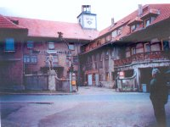

Reserve-Lazarett IX-C(a) Orthopedic Reserve Hospital
Location
In the agricultural and pastural region of Thuringia, nine kilometers South of the city of Meiningen
Opened
Erected after World War I as a boys’ school. It was later taken over by the Sturmabteilung (S.A.)—i.e. storm troopers—and then by the Hitler Youth before its conversion to a hospital.
POW Strength
Before the invasion of continental Europe patients were almost exclusively British and American air forces personnel shot down on raids over German and Europe. Strength averaged 400, at first preponderantly British. On April 5, 1943 there were 10 Americans and 178 Britons. On March 10, 1945 there were 189 Americans and 254 Britons.

Hospital Description
The main building was a large three-story stone structure. Three one-story wood and tarpaper barracks stood in the courtyard to house internal medicine cases, and a fourth barrack was used as an isolation ward. The main installation was divided into rooms comprising patient’s wards, medical officer quarters, two operating rooms—Septic and aseptic—a plaster room, X-ray room, orderlies and guard quarters.

In March 1945, a French hospital tent was erected near the Lazarett property. A water shortage plagued the hospital and latrines were insufficient when the hospital was at full strength. The aseptic operating theater became septic in July 1944 and was closed down.
Operations were then carried out in the former sterilizing room. The hospital was originally run by British POWs and retained its British staff until its liberation. In July 1944 there were 6 American orderlies and the sole American doctor on the staff remained only 3 months.
Overcrowded Conditions
In the spring of 1943 convalescents were sent to a Lazarett at Kloster Haina. In May 1944, when a strength of 540 overcrowded Lazarett IX-C(a), post-operative cases were transferred to Lazarett IX-C(b) at Meiningen, Germany.

Liberation
POWs were liberated at the beginning of April 1945 by American troops.
My dad said there were some nuns who tended to the wounded.

He also said that the patients ate bread made out of sawdust.
Dad said Gen. George S. Patton’s 3rd Army liberated the hospital. By that time, the retreating Germans were using horse-drawn carts to make their getaway.
Once liberated, Dad was placed in the back of a 2 ½-ton Army truck along with some other wounded airmen. I think Dad said he was in a body cast at the time.
Dad said there was an overly long victory celebration following the liberation in some town hall, but he decided to stay on the hard bench seat of the prime mover rather than go inside. When someone came around with a bottle of some kind of liquor, he took several big gulps to ward off the pain and the evening chill.

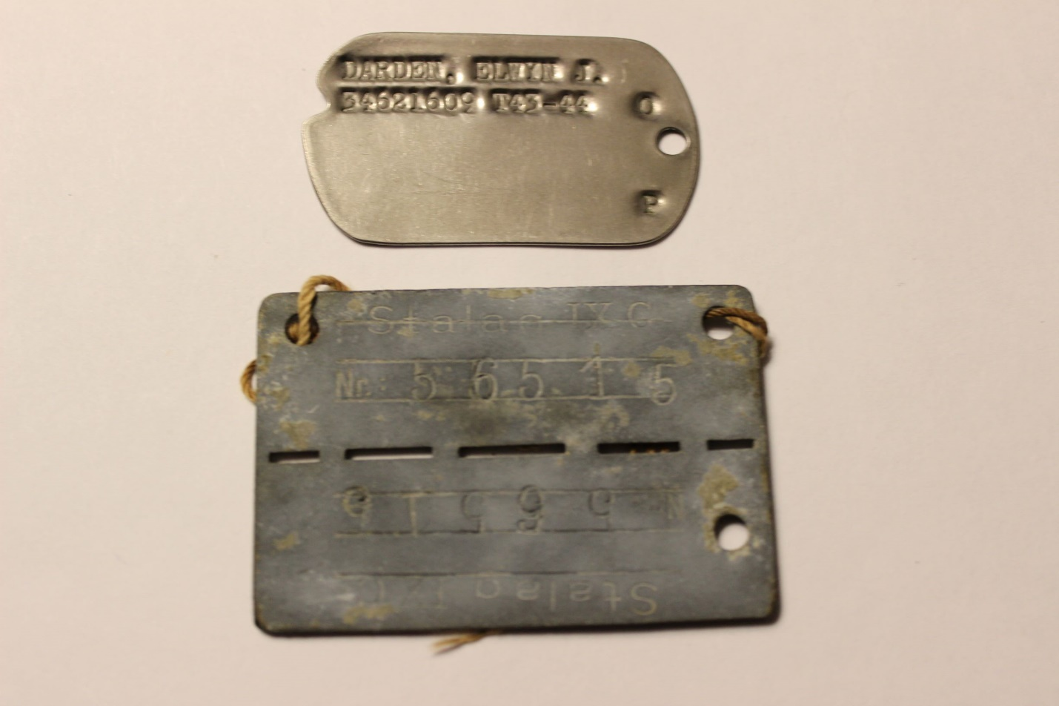
Dad’s official dog tag (above) and his POW dog tag (No. 56515) from Stalag IX-C
Following liberation, Dad said, he stayed temporarily at a German home.
While some of the other POWs were busy plundering the family’s home of all the treasures they could find, Dad said, he did end up taking a small silver spoon as a souvenir.
In addition, he said, a German woman gave him an Iron Cross—one of Germany’s highest honors—and a Nazi War Merit Cross Second Class medal that had at one time belonged to her boyfriend.
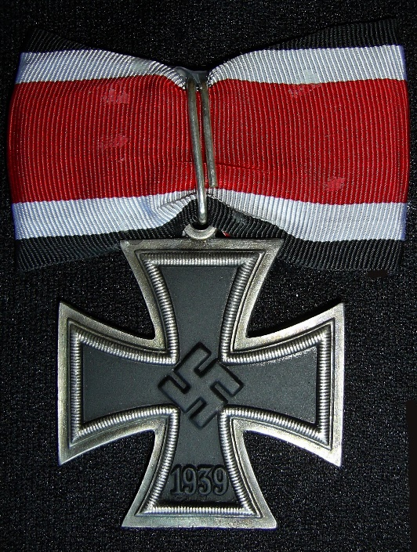
The German Iron Cross

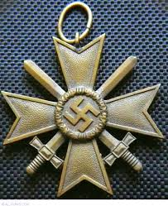
The Nazi War Merit Cross Second Class

The Plane: Post Bail-Out
Bailey, using a voice radio, had called for escort fighters to come back to help the crippled ship as it faced the German fighters. Once all the crew had bailed out—except for Bailey and Hall—four P-51 Mustangs came back and scared off the 14 Me-109s. Dad said that in that stage in the war, the Luftwaffe pilots were very green and didn’t want to tangle with Mustangs.
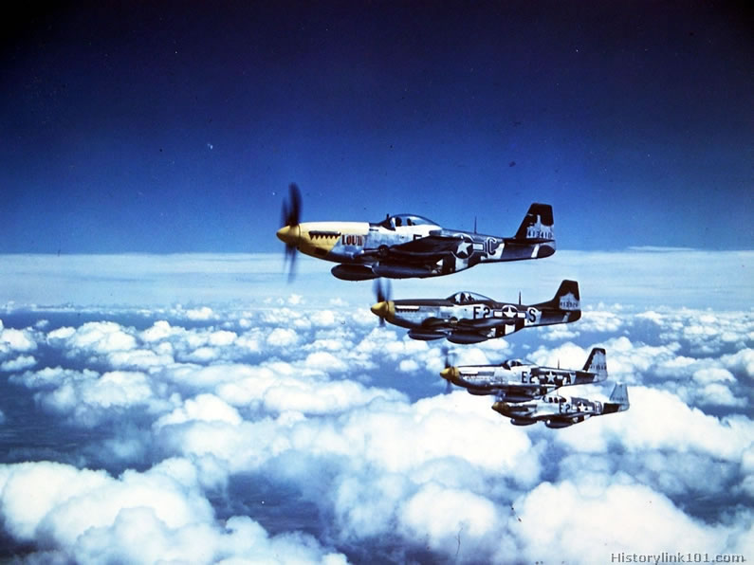
Four P-51 Mustangs, similar to these, drove off 14 German Me-109s.
Afterwards, once Bailey and Hall bailed out over liberated territory, the plane, on auto pilot, started a slow, circular descent. According to Terugblik 40-45, a Dutch magazine that Terry Eckert, Merle Eckert’s son, sent me, the townspeople of Venlo, which is near the Holland-German border, were fascinated by the “ghost plane’s” slow, almost leisurely, descent. When it came down, it struck a utility pole and then a Nazi-occupied barn.
The citizens rushed to the plane and noticed the pilot’s yokes had been secured in place by the use of seat-belts. It was reported as 90% damaged.
They were also likely looking for aviation fuel for cooking.
Mission No. 313 also saw two B-17s collide in mid-air. Of the 18 airmen on those planes, 13 were killed in action; two were POWs; and three returned to base.
(See Appendix B for Donald Geng’s recollections of bailing-out and being a POW.)

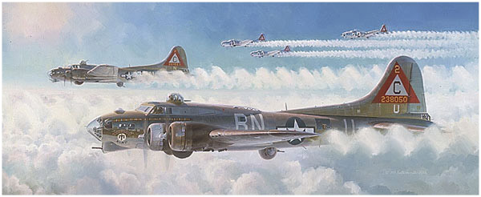
Schweinfurt Again by artist Keith Ferris shows B-17Gs from the 359th Bomb Squadron.
Reflections
Dad expressed the hope that no one on the ground was killed as a result of his plane’s bombing runs, knowing that in all likelihood, that was not the case.
I never heard him say anything negative about the German people who treated him while he was a POW.
Dad also never said anything—one way or the other—about the 303rd’s air base at Molesworth.
He did say, however, the air crews enjoyed singing and listening to the German song, Lilli Marlaine, which could have been performed in either English and German.
When asking Dad who the commanding officer of the group was, my brother read down a list and came across the name of “Lt. Col. William S. Raper.”
“That’s the guy,” Dad said dryly.
Once Dad was stateside, he underwent extensive physical therapy. He didn’t provide much in the way of details regarding his recuperation.
He attributed his ability to walk, without the aid of crutches, as a result of this lifesaving therapy.
Despite his remarkable recovery, his mother, upon his return home, greeted him with a wheelchair.
Although he never actually said it, Dad, I think, seemed to view the wheelchair as an insult.
Perhaps she was thinking her youngest son would forever be a cripple dependent upon her care.
While he did initially stay in touch with his crewmates, they eventually lost touch with one another.
When working as an aide for U.S. Senator John Stennis in the early 1950s, Dad got a call one day from Jack Bailey, who was in Washington on a visit.
“You’re a quite a big wheel,” my dad remembered Bailey saying to him.
Dad greeted him and said, “Let’s have lunch at the Aero Club.”
He never heard from Bailey again.
According to Swenson, he heard my dad was really upset with Bailey for ordering the bail-out too soon.
My dad never said anything against Bailey when we were talking about the missions.
I was able to connect with Swenson, Eckert and Geng when I did the obituary on Guy Hall in the Greenwood Commonwealth, where I worked as a staff writer in 2001.
Swenson, I believe, told me that Moose Johnson, the plane’s one-time bombardier, became a civil engineer after the war.
For his service and sacrifice, Dad was awarded of the Order of the Purple Heart and the Air Medal.
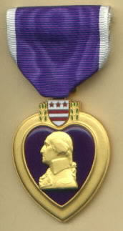
The Order of the Purple Heart

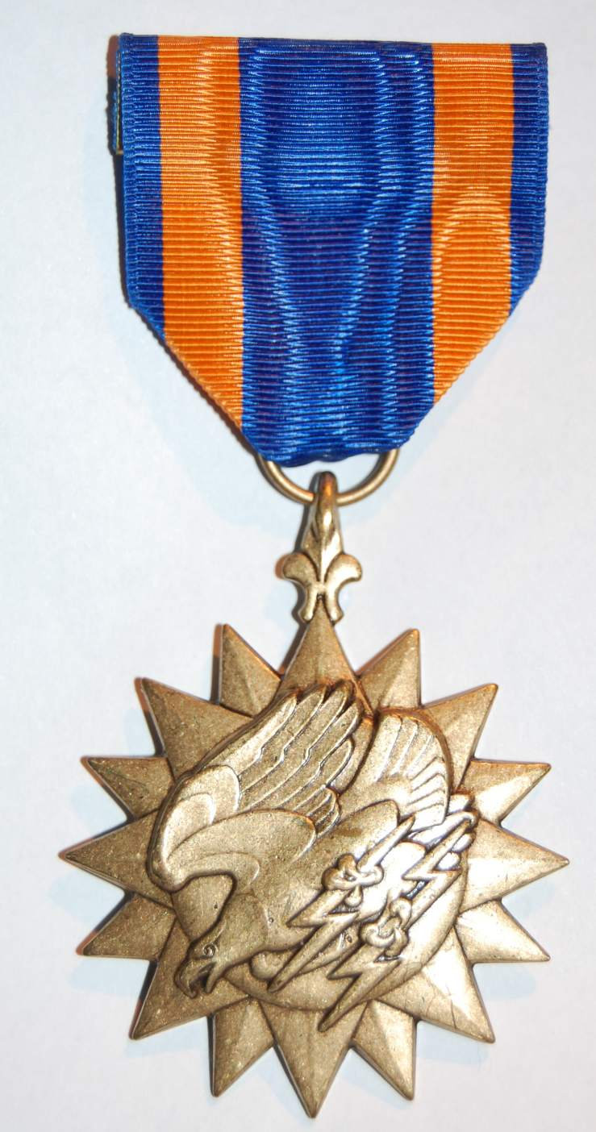
The Air Medal

Dad never made a big show of these medals. They remained in their presentation boxes on a top shelf of his bedroom closet.
Sometimes, when we were kids, we looked them over on Saturday mornings under Dad’s watchful eyes. I remember the Purple Heart being quite striking in its beauty.
I remember my sister and brother arguing over who would get the medals after Dad died—all this done in front of Dad. The answer ultimately was neither, as the medals were both consumed in a house fire in 1978.
Attempts to get a replacement set were thwarted because the Army Records Repository had sustained a major fire in 1973 in which most of the USAAF personnel records were lost, including our dad’s medal citations.
He was a member of the Caterpillar Club, which recognized fliers who were saved by an emergency parachute jump from an aircraft.
Dad never joined the Veterans of Foreign Wars or the American Legion. I think in part that was because he wanted to forget what happened to him in the war, not constantly relive it.
It wasn’t until the movie Patton came out in 1970 that Dad began to fill in the blanks about his role in “the great World War II,” as George C. Scott said in a speech portraying Patton addressing his troops.
Dad’s wounds—both physical and mental—must have taken a heavy toll on him.
I choose to remember him as a dad who loved his three children.
Once, he said to a female colleague in Senator Stennis’ office, “I’ve got to go home and count my children.”
That was my Dad.
He loved his wife, Frances, us kids, and the company of dear friends.
He also enjoyed Dave Brubeck, Dixieland jazz, and comedians Nichols & May, Vaughn Meader, Jonathan Winters, Jack Benny and Red Skelton.
Thank you, Dad, for your service to our country and for your selfless sacrifice.
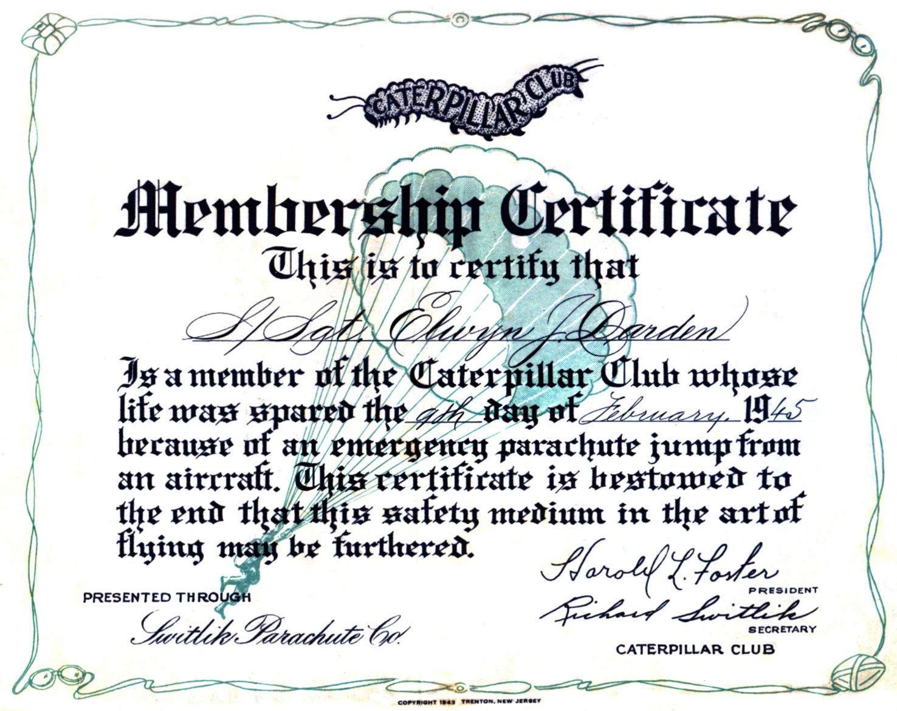
Elwyn Darden’s Caterpillar Club Membership Certificate, which was presented by the Switlik Parachute Co.

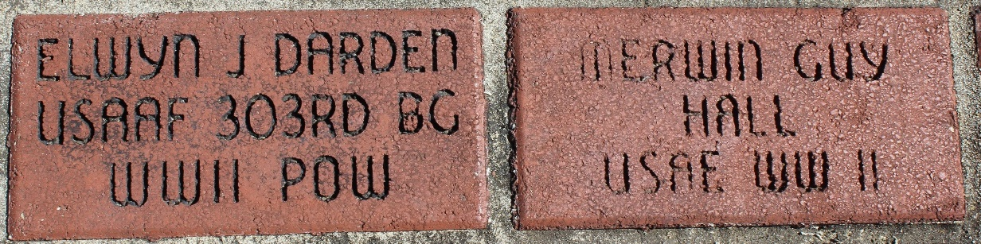
Crewmates Elwyn J. Darden and Merwin Guy Hall Memorial Markers at the Greenwood, Mississippi, Veterans Monument

Hell’s Angels: The Origins of the Name
The 303rd Bomb Group’s namesake was a B-17F, which completed its 48th mission on November 26, 1942, to Bremen, Germany. In the picture below, the crew is turning the props of the engines prior to start-up.

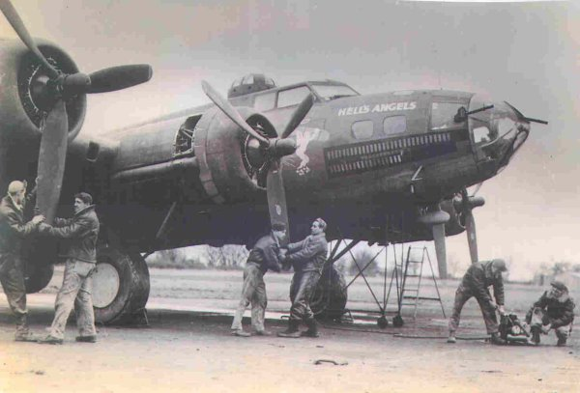
The original “Hell’s Angels”

While the official record of the 300th mission doesn’t indicate that Bailey’s plane participated, they did fly several missions both before and after the 300th mission.
Below is a letter presented to each member of the 303rd Bomb Group after completion of the 300th mission.

UPON COMPLETION OF THE 303RD’S 300TH MISSION ON 10 JANUARY 1945, THE FOLLOWING LETTER WAS SENT TO ALL GROUP PERSONNEL BY COMMANDING OFFICER, LT. COL. WILLIAMS S. RAPER:
1. “Hell’s Angels” has now completed its 300th mission. We are the first heavy bombardment group having completed this number of missions from American bases in England. The importance of this figure is that it represents our share in the total war effort of the United States Armed Forces and those of our allies.
2. We had our beginning with that small force of American heavy bombers that proved to the world that daylight, high altitude, precision bombing would play a major role in the destruction of the German war machine. During the period this group has been stationed in England, its Flying Fortresses have dropped hundreds of thousands of bombs—a total weight of over 20,000 tons—on the enemy. We know the damage and devastation of our bombing has been tremendous. The 372 enemy aircraft that our gunners have destroyed, the 101 probably destroyed, and the 180 damaged, have proven that we have been ready to defend ourselves at all costs and at all times. There is another notable fact to remember. Regardless of the number of planes with which the enemy has attacked our formation, or the type of attack they have used, they have never stopped us from bombing the target. They have never made us retreat.
3. You have every reason to be very proud of our fine record and of our war effort to date. You have all worked very hard, putting in long hours under trying and adverse conditions. Your teamwork has been magnificent, and without it our accomplishments would never have been possible. However, this war is not over, and we must all continue to do everything in our power to keep this excellent record intact, and to improve it when and where we can. Our goal is a common one—total defeat of the enemy, so that we may again return to our families, our homes, and our normal way of living.
William S. Raper Lt. Colonel, AC, Commanding

APPENDIX A
STAFF SGT. ELWYN JONES DARDEN’S
“UNLUCKY 17”
TARGET LIST
Combat Mission No. 286: 12 December 1944. Target: Leuna Synthetic Oil Refinery at Merseburg, Germany. Crews Dispatched: 38. Length of Mission: 8 hours, 15 minutes. Bomb Load: 12 x 500 lb. RDX M43 bombs. Bombing Altitudes: 25,200, 24,950 & 25,500 ft. Ammo Fired: 2,390 rounds.
Combat Mission No. 287: 18 December 1944. Target: Railroad Marshalling Yard at Koblenz, Germany. Crews Dispatched: 39. Length of Mission: 6 hours, 30 minutes. Bomb Load: 12 x 500 lb. High Explosive M43 bombs. Bombing Altitudes: 27,900, 27,200 & 30,350 ft. Ammo Fired: 0 rounds.
Combat Mission No. 288: 19 December 1944. Target: Tactical Troop Support at Blankenheim, Germany. Crews Dispatched: 39. Length of Mission: 6 hours, 30 minutes. Bomb Load: 12 x 500 lb. High Explosive M43 bombs; 12 x 500 lb. General Purpose bombs. Bombing Altitudes: 21,550 & 22,400 ft. Ammo Fired: 1,080 rounds.
Combat Mission No. 289: 23 December 1944. Target: Railroad Marshalling Yard at Ehrang, Germany. Crews Dispatched: 43. Length of Mission: 6 hours, 35 minutes. Bomb Load: 18 x 250 lb. H.E. M57 & 2x 500 lb. M17 Incendiary bombs. Bombing Altitudes: 25,600, 26,000 & 24,200 ft. Ammo Fired: 0 rounds.
Combat Mission No. 290: 24 December 1944. Target: Landing Ground at Merzhausen, near Frankfurt, Germany. Crews Dispatched: 50. Length of Mission: 7 hours, 25 minutes. Bomb Load: 30 x 100 lb. H.E. M30; 30 x 100 lb. G.P. bombs. Bombing Altitudes: 21,500, 19,000 & 21,800 ft. Ammo Fired: 3,200 rounds.
Combat Mission No. 294: 31 December 1944. Target: Railroad Marshalling Yard at Neuss, Germany. Crew Dispatched: 39. Length of Mission: 5 hours, 55 minutes. Bomb Load: 18 x 250 lb. H.E. M57 & 2 x 500 lb. M17 Incendiaries. Bombing Altitudes: 26,700, 25,600 & 28,000 ft. Ammo Fired: 3,975 rounds. Bailey’s crew had to abort this mission because of mechanical problems.

Combat Mission No. 295: 1 January 1945. Target: Railroad Marshalling Yard at Kassel, Germany. Crews Dispatched: 39. Length of Mission: 8 hours, 52 minutes. Bomb Load: 5 x 1,000 lb. H.E. M44 bombs. Bombing Altitudes: 24,300, 23,200 & 24,400 ft. Ammo Fired: 2,020 rounds.
Combat Mission No. 296: 3 January 1945. Target: Tactical Target at St. Vith, Belgium. Crews Dispatched: 39. Length of Mission: 6 hours, 10 minutes. Bomb Load: 20 x 250 lb. H.E. M57 bombs. Bombing Altitudes: 23,400, 23,000 & 24,000 ft. Ammo Fired: 940 rounds.
Combat Mission No. 298A: 6 January 1945. Target: Marshalling Yard at Cologne (Köln), Germany. Crews Dispatched: 39. Length of Mission: 6 hours, 25 minutes. Bomb Load: 2 x 1,000 lb. H.E. M44 & 2 x 2,000 lb. H.E. M34 bombs. Bombing Altitudes: 24,100, 23,800, and 24,100 ft. Ammo Fired: 400 rounds.
Combat Mission No. 298B: 7 January 1945. Target: Railroad Junction at Kall, Germany. Crews Dispatched: 39. Length of Mission: 6 hours, 10 minutes. Bomb Load: 12 x 500 lb. H.E. M43 bombs. Bombing Altitudes: 23,000, 22,200, & 23,000 ft. Ammo Fired: 5,000 rounds.
Combat Mission No. 299: 8 January 1945. Targets: Transportation Center at Schweich, Germany (GH), and Mosel Marshalling Yard at Koblenz, Germany (PFF). Crews Dispatched: 39. Length of Mission: 7 hours, 10 minutes. Bomb Load: 12 x 500 lb. H.E. M43 bombs. Bombing Altitudes: 25,500, 24,900 & 27,500 ft. Ammo Fired: 600 rounds. On this mission, Bailey’s crew flew Daddy’s Delight.
Combat Mission No. 303: 17 January 1945. Target: Railroad Marshalling Yard at Paderborn, Germany. Crews Dispatched: 39. Length of Mission: 7 hours, 15 minutes. Bomb Load: 6 x 1,000 lb. H.E. M44 bombs. Bombing Altitudes: 20,000, 23,700 & 27,800 ft. Ammo Fired: 200 rounds. On this mission, Bailey’s crew flew Forget Me Not Olly.
Combat Mission No. 304: 20 January 1945. Target: Railroad Bridge at Mannheim, Germany. Crews Dispatched: 39. Crewmembers Wounded or Killed: Lt. James Burns—DOW. Length of Mission: 6 hours, 40 minutes. Bomb Load: 5 x 1,000 lb. RDX bombs. Bombing Altitudes: 26,000, 23,700, & 27,800 ft. Ammo Fired: 0 rounds.

Combat Mission No. 308: 28 January 1945. Target: Railroad Marshalling Yard at Cologne, Germany. Crews Dispatched: 13. Length of Mission: 5 hours, 32 minutes. Bomb Load: 10 x 500 lb. H.E. M43 bombs. Bombing Altitude: 24,000 ft. Ammo Fired: 580 rounds.
Combat Mission No. 310: 1 February 1945. Target: Railroad bridge at Mannheim, Germany. Crews Dispatched: 39. Length of Mission: 7 hours, 35 minutes. Bomb Load: 10 x 500 lb. RDX M43 & 2 x 500 lb. M17 Incendiaries. Bombing Altitudes: 26,000, 25,000 & 26,500 ft. Ammo Fired: 1,050 rounds.
Combat Mission No. 311: 3 February 1945. Target: Military Objectives at Berlin, Germany. Crews Dispatched: 39. Length of Mission: 8 hours, 15 minutes. Bomb Load: 10 x 500 lb. H.E. M43 bombs. Bombing Altitudes: 24,200, 23,000 & 25,100 ft. Ammo Fired: 1,755 rounds. On this mission, Bailey’s crew flew Lucille.
Combat Mission No. 313*: 9 February 1945. Target: Synthetic Oil Plant at Lutzkendorf, Germany. Crews Dispatched: 39. Crews Lost: Lt. Nemer, 5 KIA, 1 POW, 3 RTD; Lt. Barrat, 8 KIA, 1 POW; Lt. Bailey, 7 POW, 2 RTD Crewmembers Lost or Wounded: 1 WIA. Length of Mission: 8 hours, 14 minutes. Bomb Load: 10 x 500 lb. H.E. M43 bombs. Bombing Altitudes: 25,200, 23,200, & 25,600 ft. Ammo Fired: 1,205 rounds.
*Final Mission for the Bailey Crew.
Bailey’s crew arrived at Molesworth on 1 December 1944. Most of the crew bailed out on 9 February 1945. They served a total of 70 days in theater.

APPENDIX B
MY FAITH IN GOD SUSTAINED ME:
REFLECTIONS OF A POW
BY
BALL TURRET GUNNER
SGT. DONALD GENG

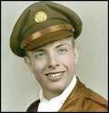

[Transcription Note: The following is a verbatim transcript of a 33-page, two-part handwritten manuscript that Donald Francis Geng (1924-2011) wrote in 2000 regarding his World War II experience in the U.S. Army Air Force and as a prisoner of war in Germany for the last three months of that war, edited by Geng’s son, Thomas W. Geng, January 2016, and for clarity here.]
On a bright, partly cloudy afternoon in early February 1945, I stepped from a crippled four-engine bomber at about 15,000 feet above the ground and headed toward enemy Germany below.
It all started that morning at 6 a.m. when I was awakened by the Charge of Quarters {crews being awakened by barrack staff}. After washing, shaving and dressing, I went to breakfast and then the mission briefing.
Our 8½-hour mission was part of a 1,300-bomber force with 800 escorting fighters sent to attack targets in Germany. Our target was a synthetic fuel plant located deep in east German territory. Plants of this type were supplying Germany with 70 percent of their fuel and therefore were fiercely defended with 200-300 flak guns (anti-aircraft artillery) and fighter aircraft.
After Briefing, the flight crews met with the group chaplains. I met with the Catholic members. The Father gave us Conditional Absolution, Communion and a Final Blessing.
We took off at 9:00 a.m., formed up in our battle formation and headed for Fortress Europe.
Four hours later found us at 25,500 feet and on our bombing run. As we neared the target the flak guns opened-up. The sky all around us was black with bursting shells.
After releasing our bombs on the target, we turned to head back home. Our two inboard engines received direct hits and were damaged so badly that they had to be shut down. We were at half-power, slowing down, losing altitude and had to leave the protective cover of our formation. We were now all alone, vulnerable to marauding enemy fighters.
We flew on alone for about 20 minutes and then were intercepted by a dozen attacking fighters. The aircraft commander (Bailey) ordered the crew to abandon the aircraft.
I was in a free fall and at about 5,000 feet I pulled the rip cord. The parachute deployed and the white nylon canopy blossomed out and stopped my downward plunge. I looked for a possible landing spot and hoped to avoid landing in the trees.
I landed in a plowed field about 200 feet from a wooded area. I collapsed my parachute, disconnected it from the harness, rolled up the parachute, grabbed my shoes and ran to the woods. I removed my parachute harness, inflatable yellow life vest, flying boots and electric slippers. Put on my shoes and tried to hide the discarded flying equipment in a brush pile.
As I started to decide where to go next, I was surrounded by a civilian search party armed with pitchforks. An old man in the party had a rifle which looked very rusty. The pitchforks looked deadly.
I raised my hands to show that I was not armed. They took me to a farm house where I was searched and my personal effects were confiscated (wrist-watch, rosary, pocket New Testament, and a pocket knife) and put into a small bag—except for the pocket knife. The old man seized the knife and put it in his pocket and would not give it up.
About three-quarters of an hour later, two uniformed armed men came and had me pick up the discarded flying gear and I was taken on a road that led to town. On the way we met two men riding a motorcycle with a side car. They were dressed in civilian clothes. They may have been members of the dreaded Gestapo.
They talked briefly with my escorts and one shouted at me something which sounded like swearing. He hit me on the back and pushed down, shouting all the time.
Arriving in town, we went to a building that looked like a government building. The escorts had me leave the flying gear in the reception area and took me upstairs to a small office. The office was occupied by a German military officer and his secretary.
The officer did not speak English but the secretary spoke very good English. I was asked to sit down at a table and given a paper and pen. I was asked to write my name, rank, Air Force unit, intended target and details of our mission. I wrote my name, rank and Army serial number and wrote that I was under orders, as a POW, and was not obligated to give any other information. The officer emptied the bag of my personal effects. He asked his secretary about the New Testament. This was the Catholic Edition of the New Testament given to me during Basic Training. The officer asked to see my “dog tags” (two identification tags worn on a neck chain).
The officer and his secretary looked over my personal effects and returned them to me. I did not see the billfold that contained 25 British pound notes. Years later it occurred to me that sometime between the time of my initial search and confiscation of my personal effects at the time of my capture, and the session with the military officer, someone probably decided to keep the billfold and paper money.
Our issued escape pouch contained German and French scrip. A few weeks prior to the last mission, it was suggested that we carry some English paper money for possible use in evasion and escape should we find ourselves in enemy territory.
After returning the New Testament, rosary, comb, and wristwatch (not a military- issued watch), the officer noticed that I had two small waxed packages in my breast pockets. I told them that these were fortified chocolate ration bars. The secretary said that the officer replied that he had a 4-year-old daughter (or maybe granddaughter) that had never tasted chocolate.
I handed one of the bars to the officer and said that it was for the little girl. He smiled and accepted the bar. I put the other bar back in my pocket, thinking a half-a-loaf is better than none.
I asked the secretary the name of the town. She said it was Eisenach. She pointed out the window to a castle {Wartburg}, which she said was where Martin Luther was kept by his friends in protective custody for over a year. While he was there, Luther translated the Bible from Latin to German.
I was then taken to a locked room in the basement where I found five other members from my crew, the navigator, togglier, top turret gunner, waist gunner and the tail gunner. They told me that our radio operator landed in a tree and fell while trying to get out of his parachute. He injured his back and was taken to a German hospital. This accounted for 6 of the 9 crew. He did not know the whereabouts of the pilot and co-pilot.
I took the chocolate bar and broke it into six pieces, one for each of us.
Later on, we met the Flight Engineer in a Prison Camp. He jumped after us and avoided capture. He wandered around for several days, and could not find anything to eat. Knowing that he was deep in enemy territory he decided to surrender voluntarily at a police station in a small town.
After the war we found out that the pilot sent the co-pilot back to the rear of the plane to make sure the other crew members had bailed-out. When the co-pilot returned to the cockpit, he found out that some of our escort fighters had chased the German fighters away. The pilot decided that he and the co-pilot would stay with the aircraft and try to fly westward and see if they could reach Allied occupied territory. One of the escorts stayed with them, but had to leave because of low fuel. They reached the Holland-Belgium border and put the plane on autopilot and jumped. They met Allied ground forces and returned to England and both finished their combat tours in early April and went home.
Ultimately, the airplane was recovered by an 8th Air Force salvage crew in March 1945. It was about 90 percent destroyed.
That evening we received our evening meal of a slice of coarse brown bread with margarine and a cup of weak beer.
The next day we were fed breakfast, some bread and a cup of imitation coffee.
The guards came and had us pick up our flight gear and marched us through town. Near the rail yards that were bombed during the night, we encountered a very angry group of civilians.
They had captured several British air crewmen whom they hanged with cords from their parachutes. They were stoning us, cursing us, and wanted to take us. Our guards were Luftwaffe soldiers, well-armed and they kept the people away. They hurried us to a siding and locked us in a boxcar. Shortly, the car was coupled to a train going east and we went to Erfurt.
We were marched to the Erfurt-Binberaleben Air Base. We were relieved of all of our flight gear, helmets and the electrical element liners in our jackets and pants. The loss of the liners meant loss of warmth and loss of our sheep skin flying helmets left us bare-headed.
We were immediately interrogated by a Luftwaffe officer. I gave him my name, rank and serial number. He wanted my squadron and group identification, home base, intended target, size of the strike force, etc. I told him as a prisoner of war, I was obligated to give him only my name, rank and serial number. He said he needed the additional information to determine if I was a spy, for which I could be executed. I said that I doubted that an American spy would be dressed in a U.S. uniform. Anyway, I would give him no further information. I further said that based on his reasoning, I would probably be executed whether I did or did not give him any needed information. In an angry mood, he said I was insolent and I would be sent to the Interrogation Center and they had a way to get the information they wanted.
We had an evening meal of their cabbage soup, black bread and imitation coffee. We were gathered up and were marched back to the railroad yards, put into a boxcar and went west. We traveled all night, stopping at times, while the train was under attack by British night fighter-bombers. We had only straw in the car to lie down on, trying to keep warm and sleep. The hunger, cold and anxiety made it hard to sleep. Even praying was difficult.
We arrived the next morning at Frankfurt/Main and were put on a tram car occupied by military and civilians for the journey to the town of Oberursel, about 7½ miles from northwest of Frankfurt.
The destination was the Intelligence and Evaluation Center-Auswertestelle West (Evaluation Center West). This large camp consisted of a cluster of low barrack-type buildings, the largest being a “U”-shaped building with the solitary cells, which was surrounded by a high-security fence. The Center processed all Allied airmen who operated from bases in England, Italy and Africa.
The building housed a reception area, offices and interrogation rooms along with solitary cells to house the POWs.
In the reception room we were instructed to hand over our dog tags and all personal items except clothing. We were given a card to write our name, rank and serial number. One dog tag was removed and kept by the clerk and the other tag on its chain was returned to us. My personal items—wrist-watch, rosary, New Testament and comb—were put in a box along with the card with my name on it.
We were then taken to our individual solitary cell rooms. The cell was about 6-by- 10 feet and about 8-feet-high. It had a high, single window with iron bars on the outside. The walls between cells were insulated and the room heated by a wall mounted electric heater. There were no pipes between the cells, which the prisoners could use to communicate between the cells. The heavy steel door had a barred window to allow the guards to check on the prisoner. The cell had a bed with straw and one blanket. We slept in our clothes. There was also one wooden chair.
The actual interrogation room reinforced the idea that you were indeed a prisoner and subject to their whims and control. It was also designed to capitalize upon your anxiety.
An officer said that the form’s information would expedite notification of the Army and Red Cross. The form did not specifically say that it was a Red Cross form but at the bottom it said, “Printed in Switzerland,” which led you to think it was a Red Cross document. I declined to give any information and said that I thought Germans were pretty efficient people and notification would be timely. He smiled and said that since I would not give any further information I would be returned to my cell.
A day or two later I was lying on the bed, when a man in civilian clothes was admitted to my cell. He said, “Don’t get up, we are not going to shoot you today.” I said, “well that’s good.” He laughed and said “only kidding.” He spoke good English with a slight accent.
He put out his hand for a handshake and introduced himself as “Herry Schmit.” He sat down and said he represented the German YMCA. (I did not know if the YMCA was active in Germany or not.)
He said his visit was to assure that I was well and well-treated. I said that I was hungry and the food was poor and sparse. He said that because of war in general and especially our bombing attacks, the German people were also feeling the effects of insufficient food—even though he looked well fed.
He then asked me where I was stationed in England, asked me where my home was in the U.S. What did I do before the Air Force? Was I a student?
I told him that I was allowed only to give my name, rank and serial number. I did say I could probably give him my birthday date. (I think I might have put my birth date down before—accidentally.)
He said that he was just curious and trying to be friendly. He said he had visited a relative in the U.S. before the war. He also said that he could tell by the “7,” “5,” and “5,” in the second, third and fourth numbers in my serial number that I was probably from the Upper Midwest of the United States. He then got up and said that he had to visit other prisoners.
The next day I was again taken to an interrogation room. The interrogator was a different person. He was friendly, asked me to sit down. He offered me a cigarette. I thanked him and said I did not smoke. He asked if I had reconsidered and wished to complete the “Red Cross” information to speed up the notification to my loved ones and expedite reception of Red Cross food parcels. I said no. No additional information would be given.
He then said, “Well, I guess we are through with you. Within the next few days when we have sufficient numbers of prisoners, we will send you to Dulag Luft at Wetzlar.” Dulug Luft was a transit camp for airmen for temporarily holding prisoners before they were sent to their permanent camp or Stalag. He said that upon leaving the Center my personal belongings would be returned to me. He stood up offered his hand and said, “Good luck.”
Except for the greeting by the “YMCA” man, which was said in jest, I was never threatened, insulted, or exposed to any unpleasantness at the Interrogation Center.
The conduct was psychological.
The loss of personal effects, solitary confinement, lack of food all contributed to damaged morale and self-respect. The solitary existence—with nothing to occupy time—was especially difficult and capitalized upon your anxiety. This anxiety itself was a fearful thing. During your captivity, the initial period of adjustment to the fact that you were a prisoner in a very hostile environment and subject to the control of a cunning enemy—and maybe a ruthless one—in spite of the general decent treatment at the Center was especially difficult.
Along with insufficient food and opportunity to exercise, sleeping was difficult. You had to realize that at a young time in your life that your well-being was in the hands of God with no family, friends or U.S. military support. Praying was even more difficult. My prayers were mostly for my family, especially my mother who was in very poor health. I prayed for the end of this terrible war and all the suffering it was causing.
We did not know about the infamous death camps. If we had I am sure our anxieties would have been much greater.
One day a group of us were assembled, were given our personal effects, boarded the tram car and went to Frankfurt under guard to the railway where we went by train about 35 miles north of Frankfurt to the Dulag Luft at Wetzlar.
The camp consisted of mostly barracks to house the prisoners. Officers were housed separate from the enlisted men. There was a mess hall, library and large meeting area.
The prison compound was governed by a senior Allied officer. At this time, it was an American colonel, a fighter pilot, captured in Italy after his plane was hit by ground fire. He welcomed us and said he would try to help make our stay as comfortable as possible.
Besides the German food rations, the camp received Red Cross parcels regularly. The normal procedure was to give the parcels to individual prisoners or they were often shared by two prisoners. Because of the transient nature of our stay at this camp, it was decided to merge the contents of the food parcels at a central kitchen and serve two meals each day. While the quality of the food was better, there was not enough to satisfy hunger.
The camp had a permanent POW staff that ran the compound with the permission of the German authorities. The Allied POW camp staff seemed to get along with their German staff.
The camp was located close to a railroad yard and not too far from a large optical works. The camp roofs were marked “POW” in large letters. There was some suspicion that the Luftwaffe moved Dulag Luft to Wetzlar and located the camp to ward off Allied bombing.
It was a very welcome change from the solitary life at the Interrogation Center. We could go outside and exercise when the weather was good.
The library had books, playing cards, chess and checkers. The library was staffed by a British Catholic chaplin who had jumped with a British parachute regiment and been captured by the Germans. The story in the camp was that he had escaped three times and had been recaptured. When you went into the library, he would greet you and ask if you wanted to go to Confession, use the books or games and if you had an escape plan.
During our stay at this camp, the POWs put on a variety show. I don’t know where they got the clothing, but some prisoners were made up to look like women. They had band instruments and formed a small band—their theme song was the tune “Time on My Hands,” which was very appropriate.
Weekly, the cigarettes that came from the Red Cross parcels were distributed equally to the prisoners. Even though I did not smoke, I decided to keep my share for bartering purposes. We had little contact with the German guards. The colonel and a small POW staff ran the compound. The colonel was a West Pointer, very disciplined and seemed to get along well with our captors. The German staff came in each morning and we had to line up for a count.
In the evening they made a tour of the prisoner’s compound to check on conditions. Occasionally, they had a surprise check. We supposed they were losing the war due to clandestine prisoner activities.
The colonel told us that it was our right to try to escape, but he did not think it wise to try to escape this camp, since we were here only a short time and the Germans were quite cooperative.
After about 10 days or two weeks we were told to gather our belongings and line up in the yard for our departure to our permanent camp at Nuremberg.
It was a cloudy day and just before leaving, the air raid sirens sounded and we could hear the approach of bomber aircraft.
The colonel told us to lie down in a deep trench along the road leading to the compound gate. From the sound of the planes, they seemed to be medium bombers that were bombing at low altitude.
We could hear the bombs hit and explode and the German flak guns firing at the planes. Since the planes were above the clouds and totally obscured, they must have been bombing by radar. We worried about a stray bomb or bombs just missing the target and hitting us.
After the air raid was over, we returned to our barracks. The next day we boarded a train on a siding and headed southeast about 200 miles to Nuremberg in Bavaria. During the night, we stopped several times to avoid traveling when Allied night fighter-bombers were looking for train targets.
We arrived on a siding on the outskirts of Nuremberg and were marched to camp. The camp, Stalag 13D, was located less than 3 miles from a large railroad marshalling yard that was a frequent target for the American and British Air Forces.
The Stalag was large but crowded because many of the POW camps in the Northeast sent their prisoners with the advance of the Russian Army toward Berlin. The filthy conditions, lack of food and the anxiety and fear generated by the frequent bombing raids by American and British aircraft didn’t help. In late February, on two successive days, the U.S. Air Force unleashed saturation bombing raids.
These were fearsome displays of power and destruction of the strategic bombing campaign as seen from the ground.
As a member of a bomber crew we had been on the bomb delivery end and could not imagine what it was like to be on the receiving end.
One of the risks for us was the falling to earth of flak shell fragments from the numerous flak batteries near the camp that were firing at the attacking bombers.
These daylight raids also showed us the progress of the bombing formation and inevitable stray aircraft that got separated from the main force. We worried that, as these strays passed over us, they would not release their bombs over the target area.
About a week later, at night, the British Air Force attacked the rail yard again.
The hundreds of flak guns firing, the colored flares dropped by the pathfinder planes to mark the target, the searchlights searching the sky, the roar of the approaching bombers, and the deafening noise of the exploding bombs created a frightening scene.
You wondered if Hell was like this.
You prayed for yourself and your fellow prisoners, the members of the British crews flying above, and also for the other people—enemy included. These experiences will remain in your memory for a long time. We prayed that no American city would ever have to endure the terror of aerial bombing.
One night about the first of April 1945, we were aroused near midnight and told to fall out and prepare to leave the camp. They kept us waiting outside for several hours. Finally, we were allowed to go back to bed. The next morning when we were assembled for a prison count, the gate to the compound opened and about 20 U.S. Army prisoners were brought in. We later talked to the new POWs and found out they were part of a tank company that went about 40 miles beyond the battlefront to liberate a POW camp. They got lost during the night and many of the tank force were killed and these were the survivors who were captured.
On April 4, 1945, the prisoners at Stalag 13D were ordered to march to Stalag 7A at Moosburg, which was about 20 miles north of Munich. After we had marched about 10 miles, the city of Nuremburg, which was regularly bombed by heavy bombers, probably from the 15th U.S. Air Force based in Italy, came before us.
A German guard just shook his head and said, “They are just turning the ruins over.” This beautiful city—a city known for the manufacture of toys—was nearly destroyed by bombing and later by artillery (it would be rebuilt after the war to its near pre-war architecture).
Later on, in the afternoon about 3 p.m. we were attacked by two P-47 American fighter planes. This happened just as we were entering a small village with a rail yard at this location.
I saw them in flight with a third plane, which provided high cover for the two attacking aircraft. The two suddenly started a dive and I shouted to my comrades to jump into a deep drainage ditch beside the road. As the planes passed over us the spent cartridges bounced on the roadway. There was a railcar with anti-aircraft guns in the rail yard and it was firing at the attacking planes. They may have been really strafing the train and not necessarily the prisoner column. We did hear that some prisoners had been wounded.
We spent the next two weeks on the road leading to Moosburg. The weather started warming up, and except for rainy days, it was nice to be in the countryside, which was quite beautiful. When it rained, we tried to find shelter in barns, but most of the time we just got very wet in the wooded areas that provided a little shelter.
The German guards could not feed us so we were dependent upon the food we brought along with us. Before we left the camp at Nuremburg, we were given Red Cross food parcels, one parcel for each two men.
Along the march route we were supplied with parcels by white-painted U.S. Army trucks manned by the Swiss Red Cross personnel. Their leader drove a 1937 Ford coupe with a 60-horsepower engine! The British POWs seemed very interested in this “typical American car.”
The food parcels were mostly from the U.S. or Canadian Red Cross. A few came from Belgium or Holland. These must have been somewhat old because at this stage of the war, these two countries were short of food as well.
The parcels generally contained powdered milk, powdered eggs, canned meat or fish (e.g., Spam, corned beef, salmon and tuna), as well as sugar, coffee, canned margarine or butter, chocolate and cigarettes.
We found the Germans on the farms and small towns friendly and willing to barter for good bread, fresh eggs and potatoes (provided they were not wormy) in exchange for sugar, chocolate and cigarettes.
We actually camped at times in order to cook and prepare our meals. Some longtime prisoners had cookers they constructed from empty cans. These cookers had blowers powered by wood pulleys, string and cranks.
The ingenuity of people is remarkable. The blowers made it possible to use paper, leaves and twigs for fuel and could heat coffee water in a very short time. Of course, because the metal from the cans was very thin, the part of the cooker at the fire would burn through. They just made new parts from additional can parts.
The people in Bavaria were probably mostly Catholic, and most farms and village gardens had little shrines with statues of Jesus, Madonna and Child, the Blessed Virgin Mary or St. Francis.
During the latter days of the march, we were often “buzzed” by American fighter planes. They would rock their wings to let us know they knew we were POWs on the move.
We arrived at Stalag 17A about the 20th or 21st of April 1945. The camp was overcrowded and dirty. Food from the Germans was nearly non-existent. We had to depend on the food we saved on the march to sustain ourselves.
The sanitary conditions were terrible. There seemed to be a lot of feces around.
The POWs in the camp were from many different Allied countries.
The permanent barracks were not sufficient in number to house the influx of all the new POWs streaming into the camp from the other Stalags. Large circus-like tents were erected to house some of the POWs. Some POWs made small “‘blanket’ tents.”
On April 28, we could hear small gun fire and the next day, tanks from the 14th Armored Division of the 3rd U.S. Army broke into the camp and we were liberated!
The next day, General Patton rode through the camp and greeted us with a big smile.

Years later, I saw the movie Patton with George C. Scott portraying General Patton. There was one scene where Scott is riding, standing up in a jeep reviewing the troops—polished helmet with general’s stars, battle jacket, riding britches and polished boots and ivory-handled revolvers. I told my wife about General Patton’s visit to the camp at Moosburg, and I said, “He looked just like George C. Scott!”
About the 9th of May, we were air-lifted to Paris. There we had our first warm shower (the first one in three months) and new clothing, and we were paid and debriefed by intelligence officers. We billeted in a hotel that was taken over by the U.S. Army and fed in a restaurant that was a temporary mess. The food was wonderful, and there was plenty of it.
The next day we were taken by truck up to a camp called “Lucky Strike” near Le Havre on the Normandy Coast. The Army set up several camps of this type to process the troops that were returning to the U.S. These camps were named after popular cigarette brands—Lucky Strike, Old Gold, Chesterfields, Camel, etc.
A few days after I arrived in camp, I was suffering from nausea. I went on sick call and a medic gave me some pills for my stomach. A couple of days later I mentioned to a soldier who shared a tent with me that I still did not feel like eating breakfast. He looked at me and said he thought I had yellow jaundice.
He said the whites of my eyes were yellow. I went to the Aid Station and asked to see a doctor. He diagnosed my illness as infectious hepatitis, caused by a virus or toxin transmitted by contaminated food or water. They sent me to a field hospital and then to a general hospital in Paris. I stayed there until about the 1st of July and then transferred to an evacuation hospital near Orly Air Field near Paris.
On the evening of July 4, 1945, I left Europe on a C-54 hospital plane and arrived at Mitchell Field, Long Island, New York. Shortly after we were settled at the hospital, a Red Cross lady brought a telephone to my bed and I was able to talk to my family—the first time in a year.
After a day or two at Mitchell Field I was transferred to a general hospital in Iowa. After a week or so there, I received a 30-day sick leave and went home. During my stay at home, the war with Japan came to an end on August 14, 1945.
After my leave was over, I reported to an Air Force convalescent hospital at Fort Logan, Colorado. I was Honorably Discharged from the Army Air force in September 1945.

Epilogue
Fifty-five years after the end of World War II it is somewhat difficult to recall many of the things that happened so long ago.
Many of the written accounts of veterans’ experiences are all based upon diaries or notes kept by individuals. When you are missing in action, your personal effects are picked up and eventually sent back to the U.S. and kept in storage for eventual return to the veteran or his next-of-kin. For some reason, my written accounts were not included in my returned personal effects.
With probably the exception of returning service men and women who chose to remain in the service, most veterans just went home and talked little about the war. Most were anxious to return to civilian life, forget the war and go back to a job or continue with their education.
For many combat veterans there might be times of reoccurring bad dreams, times of unexplored anxiety and restlessness.
Veterans of the Korean War and especially the Vietnam War seem to have suffered from what is now known as PTSD, or post-traumatic stress disorder and we now know that it was also present in World War II veterans.
The effects of PTSD can remain with you for years after the war. The fact that you tried to simply forget about that part of service that involved combat and the time as a prisoner of war probably did not help much. The services did do some psycho-counseling after repatriation from POW captivity, but little was known of the long-term psychological effects of the war, except for some very disturbed cases.
No concentration of thought or imagination can set the mind for the overwhelming idea that you are an expendable human being with a dark secret that there was an enemy out there that was trying to kill you while you were trying to do your part to prosecute the war to its conclusion.
Continued exposure to this action does not dull the sense that you will overcome this fear or anxiety in subsequent actions. Safety becomes impossible and only preoccupation with your busy assigned tasks aids toward your self-preservation.
It is the time after the mission that you actually have time to think about it.
That really works on your mind.
A particularly bad period for a POW is when you are in solitary confinement where there is no outlet and an infinite amount of time.
“Do you pray?”
Yes, when you can.
However, at some point even praying becomes nearly impossible. You realize that you are not in charge and that, as a prisoner, even your own military does not have control over you. You are at the mercy of the foe. You are constantly in danger and only your faith sustains you.
Yes, you do pray at the most difficult times for your well-being.
During the less immediate times, you pray that you will fulfill your sense of honor and duty and be a leader for your comrades in the Army. In addition, you pray that your family will be OK. Try not worry and trust that things will work out.
You also pray that the war will come to a quick end and a just peace will prevail. You also pray that war—particularly the Air War—will never come to your homeland.
You also think and pray for the foe, especially for the young and old, caught up in the cities during the bombings.
“What are the other consequences of your wartime experiences?”
You hope to return to a peaceful world, find civilian life in some worthwhile pursuit.
You realize the value of family and friends. You work for a strengthened spiritual life.
There is a realization that most of the people in the world simply want to live good, productive lives, want enough peace and prosperity for a happy life.
At the same time, you are also aware of the evil side of many who seem to want to satisfy their greed for power and material wealth.
Experiences as a Prisoner of War teach you basic psychology and are a course in human relations.
One final thought.
I have been without my wife for 10 years. She was my best friend and without her, life at times is very lonesome. At times, when I return to an empty house after being away, I find her loss causes a great deal of lonesomeness.
Not having that special person around to love and care for is difficult.
Now, and as it was back 55 years ago, it is my faith in God that sustains me.

APPENDIX C

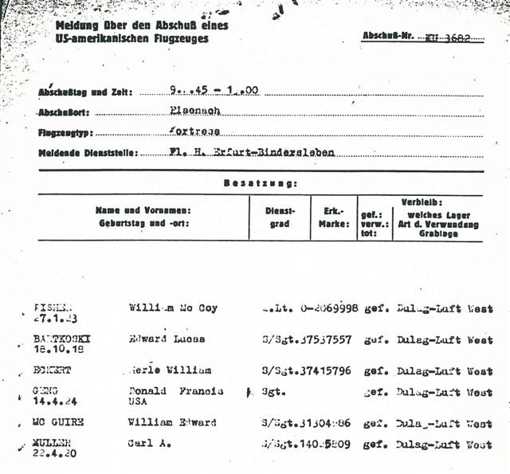
German document reporting the capture of the Jack Bailey Crew. Note that Staff Segeant Elwyn Jones Darden’s name is not listed, as he was injured and was taken to Stalag IXC, a POW Camp Hospital, not Dulag-Luft West.

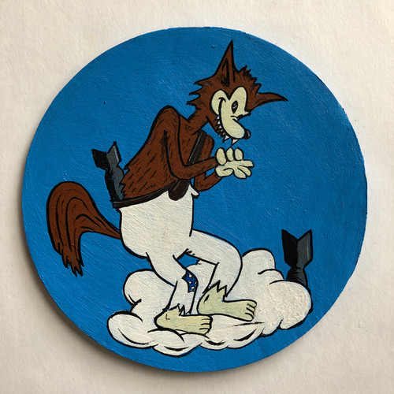
The 359th Bomb Squadron’s Mascot.

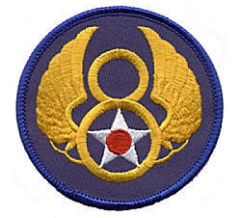

The Insignia of the Eighth Air Force, United States Army Air Corps.

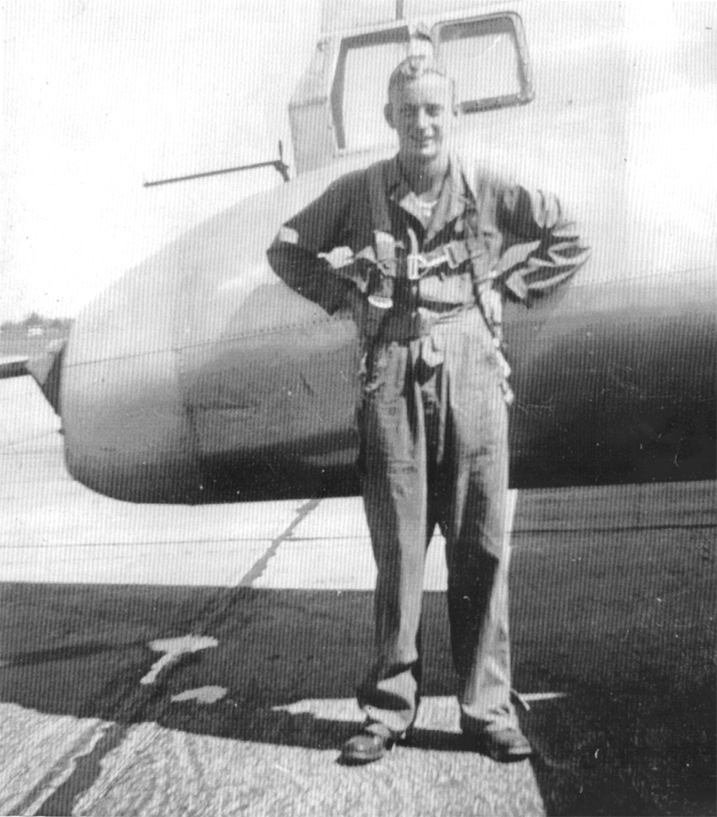
Staff Sergeant Elwyn Jones Darden stands “at ease” in a snapshot taken by Lieutenant David “Moose” Johnson, the bombardier of the Jack Bailey Crew.

